Camping Menina internship description

Camping Menina is excited to welcome students and young professionals who are passionate about the tourism industry to join our reception team in an exciting and unique internship! If you are someone who loves connecting with people, staying organized, and thriving in a fast-paced environment, this is the perfect opportunity for you.
As a Reception Intern, you will be the friendly face of our team, greeting guests and making sure everyone feels at home. You will help answer questions, manage bookings, assist with daily office tasks, and keep things running smoothly for our team. This position requires someone who is organized, and flexible with strong interpersonal skills. You will work closely with the rest of the team, learning the ins and outs of managing a busy reception while providing excellent customer service. Our team is based in the Upper Savinja Valley in Slovenia, surrounded by breathtaking landscapes and a rich local culture. The internship will expose you to all aspects of operations at a busy outdoor and adventure destination, from interacting with guests and locals to handling administrative tasks and assisting with event coordination. We’re looking for someone who is quick on their feet, eager to help, and excited to take on a variety of tasks — whether it’s organizing reservations, helping out with special requests, or lending a hand to the team with anything that pops up throughout the day. This is an amazing opportunity to develop valuable skills in communication, organization, and customer service in a fun and dynamic setting.
Think you are the perfect candidate? Review the guidelines and information below for more details and please reach out with any questions. We look forward to connecting with you!
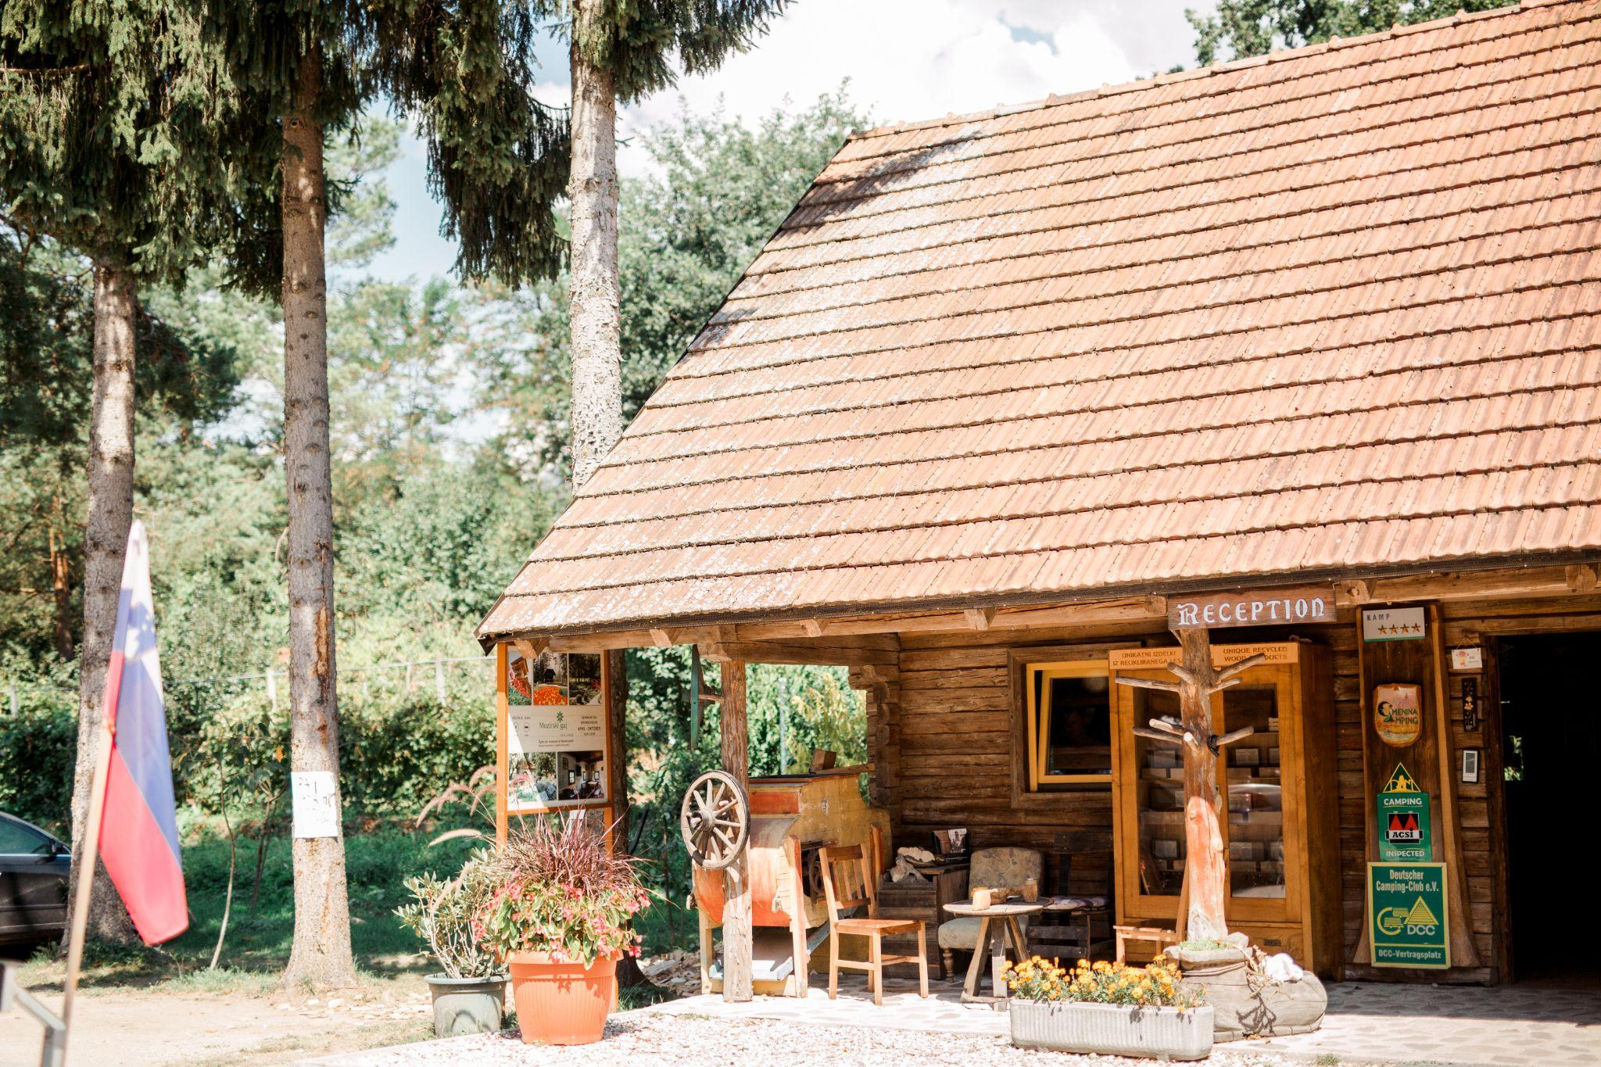

SKILLS GAINED FROM THE INTERNSHIP:

Reception interns at Camping Menina will operate as an integral part of our team, gaining hands-on experience in customer service, office management, and the operations behind the campsite. As part of our reception team, interns will have the opportunity to:
- Work alongside our reception staff from the start to finish of each guest's stay, assisting with check-ins/outs, handling inquiries, and providing helpful information. You will learn everything there is to know about running the front desk in a lively environment, including managing bookings and addressing guest needs.
- Earn knowledge in customer care/service, learning the best practices for providing exceptional service to a diverse group of guests, from outdoor adventurers to local visitors.
- Expand on organizational and communication techniques, including how to engage with guests and staff, coordinate activities, and ensure that all administrative tasks run smoothly behind the scenes.
- Develop problem-solving skills in a customer-facing role by addressing guest concerns, offering creative solutions, and improving your ability to think on your feet.
- Hone your communication skills, both in small and large group settings, as you interact with guests and other staff members. You’ll become comfortable with both in-person and phone communication, learning to convey information clearly and professionally.
- Gain a greater understanding of the behind-the-scenes work that goes into providing a smooth experience for guests and keeping operations running smoothly — from handling paperwork to managing bookings and special requests.
- Build confidence and take on more responsibility, helping with a variety of administrative tasks while contributing to the overall guest.
The possibilities are endless, but the core mindset is the same — assist our team in making sure that every guest has a smooth, enjoyable stay while supporting the behind-the-scenes logistics to ensure everything runs seamlessly. Whether you are answering questions, managing bookings, or helping with special requests, this internship will offer valuable experience and professional growth in a fun, dynamic setting.

IDEAL CANDIDATE:
This internship is perfect for candidates interested in tourism and eager to develop their communication, problem-solving, and organizational skills in a fast-paced environment. If you are passionate about customer service and looking to grow in a professional setting, this is for you! We know you are still learning, and that is okay – we are looking for someone ready to take on responsibilities, assist guests, and contribute to a smooth reception operation. If you're excited about gaining real-world experience in tourism and making a positive impact on guest experiences, this internship is a great opportunity for you!

